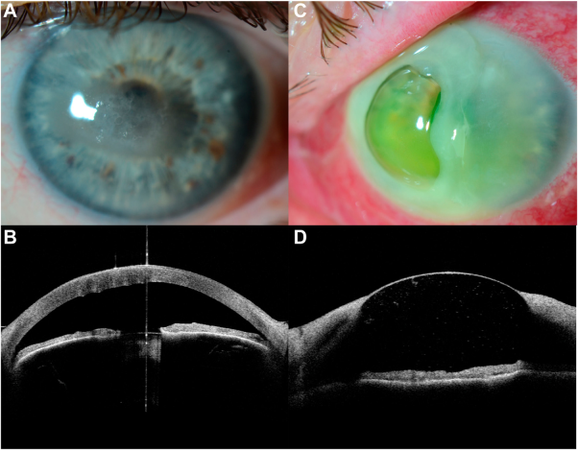

A 62-year-old man presented with bilateral band keratopathy (A, anterior segment [AS] photography; B, AS-OCT) with no otherrelevant systemic or ocular findings. The patient was treated with topical ethylenediaminetetraacetic acid (EDTA) 2% twice daily bilaterally. The patient reported acute vision loss in his left eye 20 days later. He showed a severe descemetocele with surrounding stromalmelting and anterior chamber inflammatory response (C, AS photography; D, AS-OCT). His right eye showed no significant changes. Based on the provided images and clinical description please make an ophthalmic diagnosis for this patient. And output the diagnostic conclusions only

**Descemetocele with stromal melting**